Testing 10mm 13cm vs 20mm40cm parameters:

Model 4: Force = (a0 + a1(e/emax))\*pressure + a2(e/emax) + a3;

Force = a3 + a2\*(relative strain) + (ao + a1\*relativestrain)\*Pressure

Regression analysis:

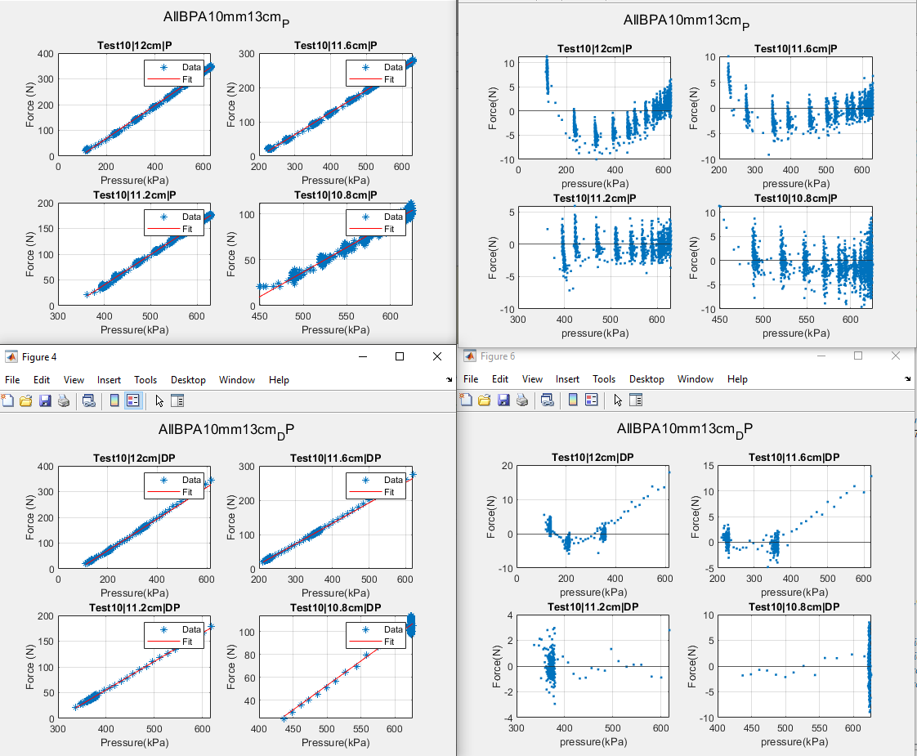

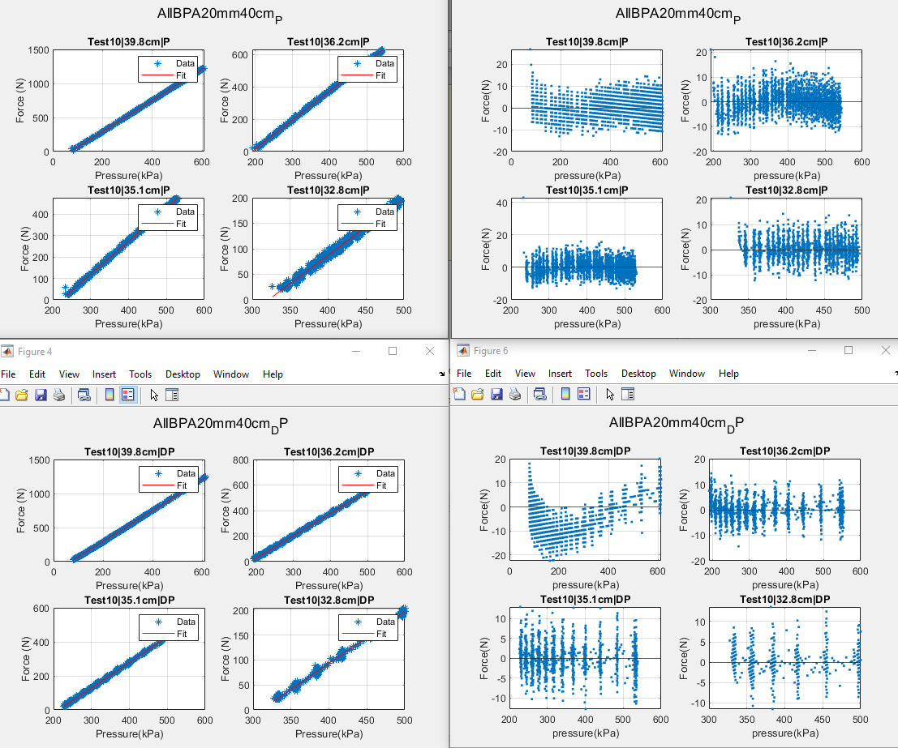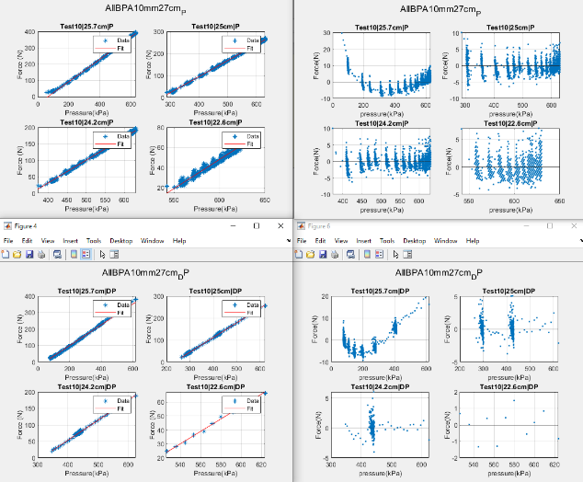

\

10mm13cm

10mm27cm

20mm40cm